Dashboard Design

|  |  |
| --- | --- |
| Date | 19 March 2025 |
| Team ID | LTVIP2025TMID48739 |
| Project Name | Visualizing Housing Market Trends: An Analysis of Sale Prices and Features using Tableau |
| Maximum Marks | 5 Marks |

Visualizing Housing Market Trends: An Analysis of Sale Prices and Features using Tableau

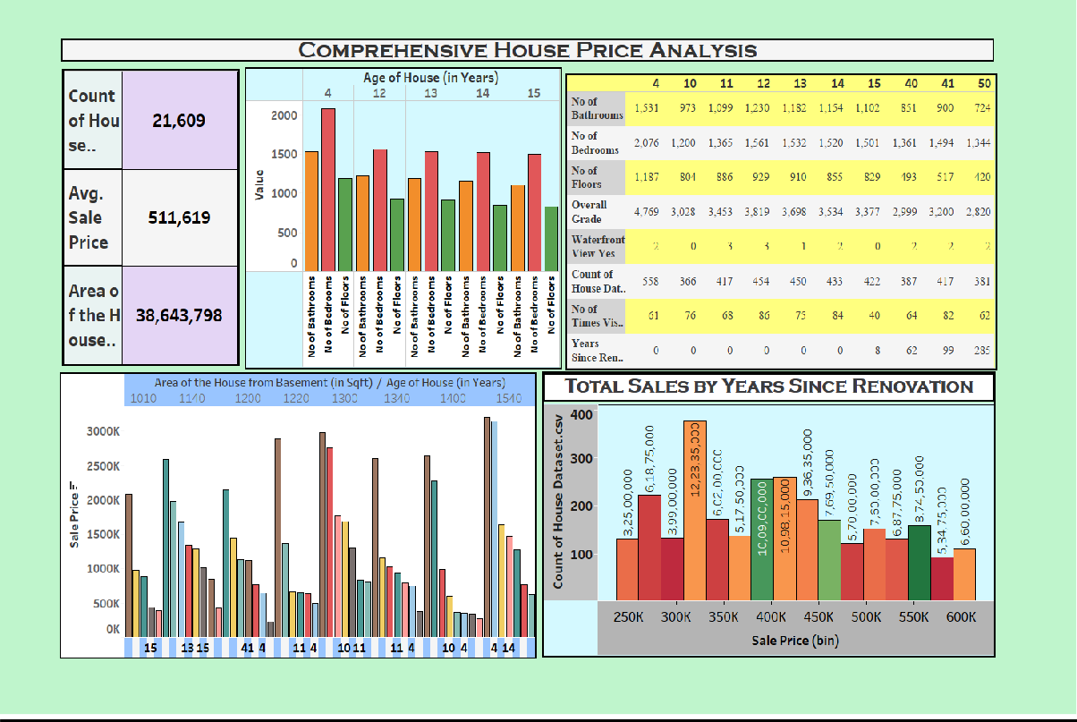**DASHBOARD**

1. **Total Number of Houses Analyzed:** The dataset contains **21,609** houses records, providing a substantial basis for analysis.
2. **Average Sale Price:** The average sale price of houses in the dataset is

**$511,619**, offering a reference point for market trends.

1. **Total Area from Basements:** The total basement area of houses analysed sums up to **38,643,798 sqft**, indicating the extent of properties with additional underground spaces.

# Sales Trends Based on Renovation Age:

* + Houses priced at **$300K** have the highest number of sales, exceeding **380 transactions**.
  + Sales are influenced by the years since renovation, with variations in total counts and price bins.

# House Age Distribution by Renovation Status:

* + The pie chart highlights different age groups of houses based on their renovation history.
  + Houses aged between **50 to 118 years** contribute significantly to the market.

# House Age Distribution by Number of Bathrooms, Bedrooms, and Floors:

* + Properties aged between **12 to 15 years** show variations in the number of bathrooms, bedrooms, and floors.
  + A correlation can be observed between house age and structural characteristics.

# Age of House & Features Impact:

* + Houses aged 4 to 15 years have varying numbers of bathrooms, bedrooms, and floors.
  + The overall grade of houses decreases as the house age increases.
  + Very few houses have waterfront views.

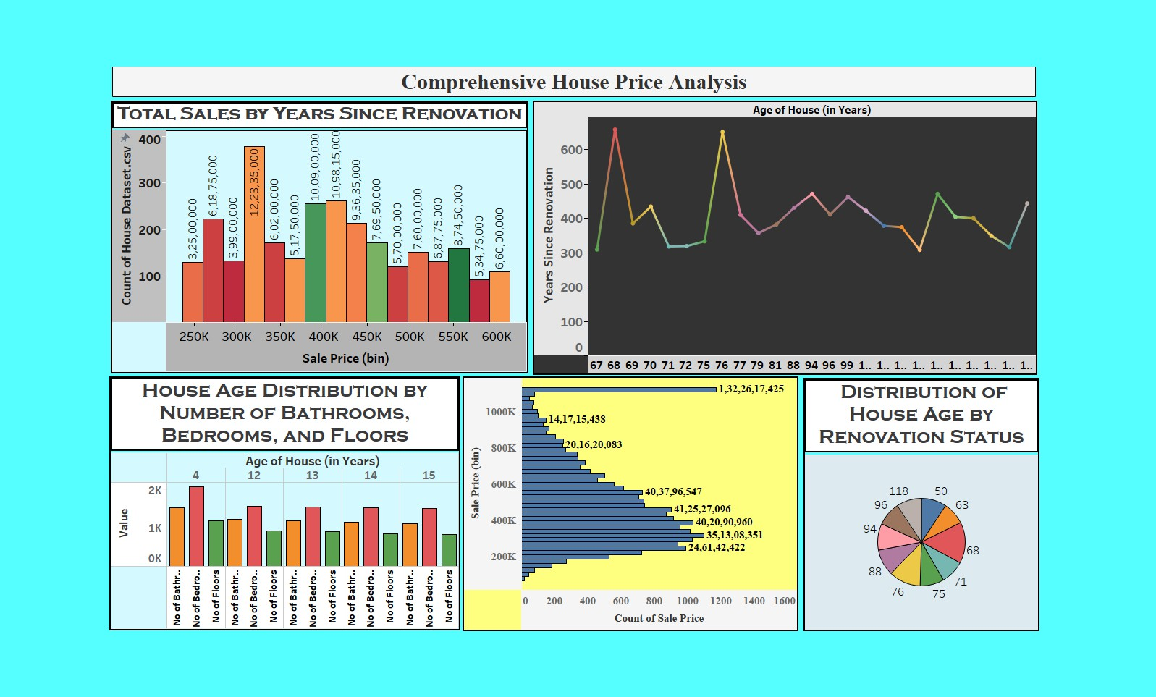

1. **Total Sales by Years Since Renovation:** Displays sale price distribution based on years

since renovation. Houses in the $350K price range have the highest sales volume, indicating strong demand.

# House Age Distribution by Number of Bathrooms, Bedrooms, and Floors:

A bar chart

analyzing house age concerning key house features. More bathrooms, bedrooms, and floors

appear in a similar age range, implying consistent architectural trends over time.

1. **Distribution of Sale Prices**: Houses priced between $200K-$600K have the highest sales

count, showing they are the most popular. Luxury homes ($1M+) contribute significantly

to total sales volume but have fewer transactions.

1. **House Age by Renovation Status:** A pie chart indicating house age distribution for

renovated homes. Older homes (76, 88, 96, 118 years) seem to be more commonly

renovated. Highlights the necessity of renovations in aging properties to keep them marketable.

1. **House Age vs. Years Since Renovation:** A line chart showing the correlation between

house age and renovation status. Peaks in the graph indicate houses that have gone

through major renovations over time. Suggests that older homes may require frequent

renovations to maintain their value.

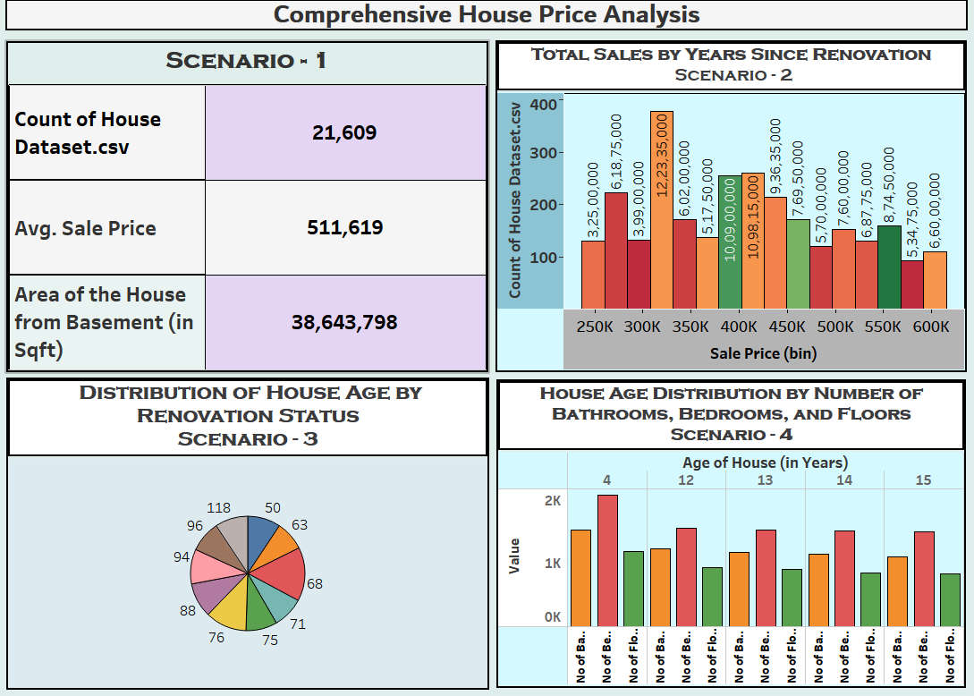

Scenario 1 - General House Dataset Overview

* + The dataset consists of 21,609 houses.
  + The average sale price is $511,619.
  + The total area of houses, including basements, is 38,643,798 sqft. Scenario 2 - Total Sales by Years Since Renovation
  + A bar chart displays sales price bins ranging from $250K to $600K.
  + The highest number of sales seems to be in the $350K range. Scenario 3 - House Age and Renovation Status
  + A pie chart shows the distribution of house age based on renovation status.
  + Various segments represent different house ages.

Scenario 4 - House Age Distribution by Number of Bathrooms, Bedrooms, and Floors

* + A bar chart indicates the distribution of house ages (4 to 15 years) based on the number of bathrooms, bedrooms, and floors.
  + The number of bathrooms seems to have a strong correlation with house age.